# FLOATPLANE TEST

# tr00067_

**DO NOT WRITE ON THIS TEST**

**References:** FAA-H-8083-23 Seaplane, Skiplane, and Float/Ski Operations Handbook

How to Fly Floats (EDO) by J. J. FREY

1. When pre-flighting the floatplane you should assure the following:
   1. There are no buckled struts or damaged fittings.
   2. Cables and rigging wires are not worn or loose.
   3. Not more than a capful of water remains in each float compartment.
   4. All of the above.
2. When starting the floatplane’s engine, be sure of the following:
   1. The aircraft and floats are untied from the dock or tie-downs.
   2. The float plane is pointed away from other aircraft, docks and boats.
   3. The floats are not sitting on the bottom.
   4. All of the above.
3. When taxiing the floatplane the following rule should be observed:
   1. Always taxi as fast as possible.
   2. Hold the controls all the way back.
   3. Taxi with the water rudders up.
   4. Taxi with the flaps down to prevent excessive taxi speed.
4. The proper power setting for slow taxiing is:
   1. Approximately 1500 RPM.
   2. Below 1000 RPM and stick full aft.
   3. Not high enough to cause a pitch change or bow spray.
   4. Both B and C.
5. When bow spray is caused by taxiing fast, it can damage:
   1. the floats.
   2. the engine.
   3. the propeller.
   4. the cowling.
6. Water rudders are usually more effective at high speed because they move in conjunction with the air rudder.
   1. True
   2. False
7. When making step turns, the wind and centrifugal force can:
   1. Cancel each other out when turning from upwind to downwind.
   2. Act in the same direction when turning from downwind to upwind making the aircraft unstable.
   3. Cause the downwind float to dig in and cause the aircraft to capsize.
   4. All of the above.
8. The proper sequence for getting on "step" is:
   1. Full power, water rudders up and stick full aft.
   2. Water rudders up, full power, stick full aft.
   3. Area clear, water rudders up, full power, stick full aft.
   4. Area clear, water rudders up, stick full aft, full power.
9. To stabilize a seaplane during a high speed taxiing turn, you should:
   1. Turn from an upwind to a downwind.
   2. Turn from a downwind to an upwind.
10. The water rudders may only be left down for takeoff under what conditions?
    1. All the time.
    2. On a wide waterway.
    3. To assist in weathervaning control.
    4. To decrease turn radius.
11. Before the takeoff run is started, assure the elevator trim is adjusted to give:
    1. Nose down trim to get on step quicker.
    2. Nose up trim to get off the water quicker.
    3. Normal takeoff trim to avoid high control pressure.
    4. Proper attitude for the A/C gross weight.
12. During the takeoff run on step, porpoising is encountered. What should the pilot do to correct this?
    1. Change the pitch angle.
    2. Change the power setting.
    3. Pull off all power and hold full aft stick, and start takeoff again.
    4. Apply more flaps.
13. Glassy water takeoff will decrease drag making acceleration and lift-off less difficult.
    1. True
    2. False
14. The direction the wind is coming from on a lake is most easily determined by?
    1. No specific technique is available.
    2. Contacting flight service.
    3. Holding your hand out the window.
    4. Identifying the calmer portion of the lake near the shoreline.
15. When landing at unfamiliar waterways, you should:
    1. Land at lower speed.
    2. Land normally.
    3. Make a low pass and check for logs, shallows, or rocks.
    4. Make a touch and go first.
16. A normal landing technique is:
    1. Full flaps, normal approach speed and power on the landing slightly tail low.
    2. Full flaps, power off, stick full aft.
    3. No flaps, half power, stick forward.
    4. Full flaps, power off, level attitude.
17. Glassy water landings are?
    1. The easiest type of landing to make.
    2. Difficult because of the lack of depth perception.
    3. Of concern because the floats encounter a substantial amount of surface friction on contact with the water.
    4. B and C only.
18. A glassy water landing technique is:
    1. Full flaps, power off, land in the center of the waterway.
    2. Establish a stabilized approach and set up for a short field landing.
    3. Fly the approach parallel to the shoreline to judge height, full flap, power on with the nose up attitude with maximum 150 FPM rate of descent. At touchdown apply back pressure and close the throttle.
    4. Land using no flaps.
19. When landing in rough water the appropriate technique is?
    1. No flaps, no power, a flat glide slope and high airspeed.
    2. Landing in rough water is impossible because the airplane will flip over.
    3. Full flaps, a medium power setting similar to a soft field landing on wheels.
20. Which landing requires the greatest landing distance?
    1. Normal
    2. Rough water
    3. Glassy water
    4. No flaps
21. Float flying is most hazardous during what conditions?
    1. Glassy water
    2. Rough water
    3. River currents
    4. At night
22. Night landings on floats are:
    1. Encouraged to build piloting skill and depth perception.
    2. Extremely hazardous and should be avoided where possible.
    3. Done when encountered by using the glassy water technique, but be avoided where possible because of severe lack of depth perception.
    4. Only recommended if you have at least one operable landing light.
23. Six Mile seaplane traffic should:
    1. Announce takeoff and taxi movements and landing intentions on 122.9.
    2. Announce takeoff and taxi movements and landing intentions on 127.2 (EDF tower).
    3. Maintain radio silence.
24. Aircraft landing West at Six Mile should use a:
    1. Left hand traffic pattern.
    2. Right hand traffic pattern.
25. Traffic pattern at Six Mile Lake is:
    1. 500 feet AGL
    2. 500 feet MSL
    3. 600 feet AGL
    4. 600 feet MSL

**FLOAT COMPONENTS**

**35**

**Front**

**Back**

**31**

**30**

**28**

**26**

**43**

**42**

**41**

**40**

**39**

**38**

**37**

**33**

**34**

**32**

**29**

27

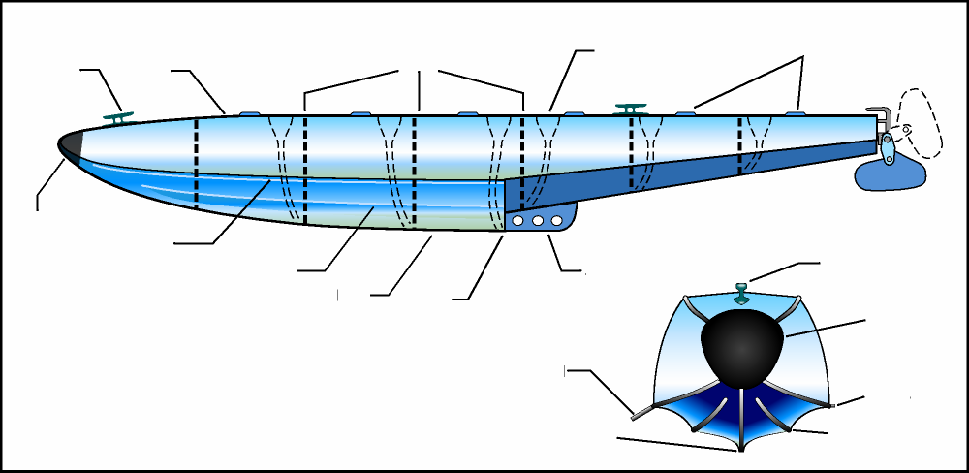

**36**

Select the correct answer from Column B and place in Column A. Every number has a name and a name can be used twice. Put these answers on the answer sheet. You must also know these components for the FAA Checkride.

1. A. Bumper
2. B. Hand Hole Covers
3. C. Skeg
4. D. Chine
5. E. Bow
6. F. Sister Keelson
7. G. Step
8. H. Water Rudder
9. I. Deck
10. J. Stern
11. K. Keel
12. L. Mooring Cleat
13. M. Bilge Pump Openings
14. N. Spray Rail
15. O. Bulkheads Dividing Watertight Compartments